**Assignment # 02:**

**Question # 1:**

*max time=45 minutes*

**Mr Uzumaki** wants to send a private message to **Mr Namikaze**; the only way for communication is an unsafe medium so he decided to secure his message by using an Asymmetric Key Encryption in which a private key of a person is used to encrypt the message and a public key is used to decrypt that message. **Mr Uzumaki** has designed an algorithm that accept a private key and generates its corresponding public key. Unfortunately, he is week in programming so you have to help him by implementing the algorithm in C language. The algorithm is simple.

1. Take 8 digits (non-negative) private key.
2. Split the key in half.to make two sub-keys.
3. Subkey one S1 = left most 4 digits
4. Subkey two S2 = right most 4 digits
5. Take two non-negative integers p and q.
6. Modulo each digit of S1 with p and add q.
7. Modulo each digit of S2 with q and add p.
8. Now append S1 and S2 that is the Public key.

**Question # 2:**

*max time=30 minutes*

Write a function to print triangle pattern up to nth rows using loop.

For example: triangle with **6** rows.

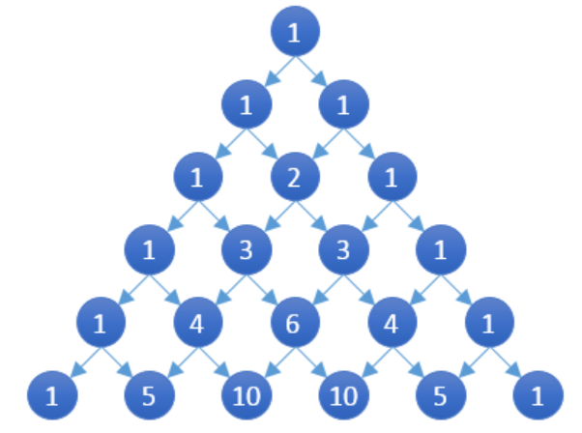

**Question # 3:**

*max time=30 minutes*

**Najaf** is weak in mathematics. He has an assignment to do which he is not so sure if he has done right or wrong. The assignment requires to find out if a number is an Armstrong Number or not. Showing all steps was mandatory in the assignment. He has somehow completed his assignment, now he wants to ensure if the answers are right. So, he has hired you, ***The Best Programmer***, to help him.   
Example 1) => 163  
(1 ^ 3) + (6 ^ 3) + (3 ^ 3) => 1 + 216 + 27 = 244 (Not Armstrong Number)  
  
Example 2) => 153  
(1 ^ 3) + (5 ^ 3) + (3 ^ 3) => 1 + 125 + 27 = 153 (Armstrong Number)

**Question # 4:**

*max time=30 minutes*

**Mr. Ahmed** has **5** children Ali**, Hamza, Jasia, Lubna and Rubab**. Ali is youngest. Every day while returning home Mr. Ali buys chocolates according to the current date. (e.g. on 5th Dec 2010 he would buy 5+1+2+2+0+1+0 = 11 chocolates).

**Question # 5:**

*max time=30 minutes*

**Develop** a solution to change Roman numerals into their decimal equivalents. Consider all possibilities of Roman numerals—no letters, only one letter, two letters, and so forth. Assume that the Roman numerals are in correct order. One Roman numeral character is entered at a time. The Roman numeral is entered from left to right. Roman numeral equivalents are as follows:

I = 1, V = 5, X = 10, L = 50, C = 100, D = 500, M = 1000

Examples of input numbers are IV, XIX, MMCDXL, and CCLV.

**Question # 6:**

*max time=30 minutes*

**Affan** wants to withdraw some cash which he needs urgently. He doesn’t have time to go to the bank and goes through the lengthy procedure of filling the withdrawal receipt and wait for his turn. So, he decided to get that amount from an ATM near his place. He went to the ATM and entered his card in the slot, entered his PIN code. Everything went smooth. Now he enters the required amount and collected the cash, counted it and walks out of there. He wants to know how much amount will result in how many notes.  
Things to keep in mind:  
The ATM can give out only Rs.100, Rs. 500, and Rs.1000 notes. Therefore, amount must be entered keeping that point in mind.

**Question # 7:**

*max time=30 minutes*

**Pediatric Doctor** of Osteopathic wants a software solution for pediatric norms of children, to guide parents about the height and weight deviation of their children. The software have to evaluate the status of the height and weight, taking into account each child's level of growth. Children are defined as deviating from height and weight norms if their height or weight are either lesser or greater than the age norm for their own age. Provided the standard values of height and weight norms you are required to design the application on C defining two separate functions for height and weight norms.

**Approximate Weight Per Age:**

When age is above 1 year [Weight in kg = (8 + (2 * years)]

When age is below 1 year [weight in kg = (4 + (6*years)]

Newborn: 4 kg

6 months: 7 kg

1 year: 10 kg

**Approximate height Per Age:**

[Height in cm = (75+ (7*years)]

**Question # 8:**

*max time=30 minutes*

Write a program which reads characters one at a time until EOF (End of File). It prints out each identifier (e.g. “Quaid e Azam” = 3 identifiers). When user terminate input it should count all the identifiers.

1. It should ignore white space as delimiter for an identifier.
2. Identifier should start with an alphabetic letter and may be followed by any number of letters OR digits. (e.g. apple1, a, hello)
3. These characters “symbols”, (~! @#$%^&*() _+=) are considered illegal.

**Question # 9:**

*max time=20 minutes*

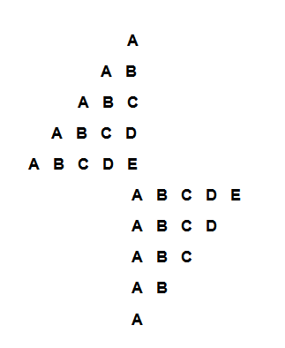Generate the following output

**Question # 10:**

*max time=30 minutes*

Using the recursion technique, develop a solution to calculate the power of a number, given the number and the exponent.

**Question # 11:**

Write a solution to find the average miles per gallon on a car after six fillups at a gas station. Additional data kept included the number of gallons of gas at each fill up, the starting odometer reading, and the odometer reading at each fillup. (Use Arrays for this Question)

**Question # 12:**

*max time=30 minutes*

Mr. Johnson would like to know how many As, Bs, Cs, Ds, and Fs his students received on a test. He has 10 students who took the test. He would like to enter the student number and the number grade for the test for each student. Develop the solution to print out each student’s student number, number grade, letter grade, and the total number of As, Bs, Cs, Ds, and Fs. His grading scale is as follows: 90–100 is an A, 78–89 is a B, 65–77 is a C, 50–64 is a D, and below 50 is an F.